Digital Campus Business Requirements Document

Votary Softech Solutions Pvt. Ltd.

Plot No: 76, Lumbini layout,   
Near Euro school,   
Gachibowli-I (V), Hyderabad,  
Telangana - 500032,   
India.

**Revision History**

|  |  |  |  |  |  |
| --- | --- | --- | --- | --- | --- |
| Version (x.y) | Date of Revision | Description of Change | Reason for Change | Affected Sections | Approved By |
|  |  |  |  |  |  |
|  |  |  |  |  |  |
|  |  |  |  |  |  |

**Approval History**

|  |  |  |  |
| --- | --- | --- | --- |
| Version (x.y) | Prepared By | Reviewed By/Date | Approved By/Date |
|  |  |  |  |
|  |  |  |  |
|  |  |  |  |

**Contents**

1 Define

1.1 Objective 4

1.2 Deliverables 4

1.3 Prerequisites 4

1.4 Assumptions 4

1.5 Limitations 4

1.6 Business Risks 4

1.7 Glossary 4

2 Specify 5

2.1 Scope 5

3 Architecture 6

3.1 Block Diagram 6

3.2 Internal Interfaces 6

3.3 External Interfaces 6

4 Design 7

4.1 Flowcharts 7

4.2 Development Environment 8

4.3 IP Identified 8

5 Implement 8

5.1 System Requirements 8

5.1.1 <Module based> Functional Requirements 8

5.2 User Acceptance Criteria 9

5.3 Quality Plan 9

# 1 Define

Digital Campus has capabilities to detect employee BLE/BT tag location through standalone gateways, In-time out-time, Dwell times of employee

## 1.1 Objective

Purpose of this project is to locate, track employee through BLE/BT tag and to get hands on experience to Engineer’s from LC on a project life cycle

## 1.2 Deliverables

* Digital Campus Gateway
* SQL Database
* User Application (Desktop/Mobile)

## 1.3 Prerequisites

NA

## 1.4 Assumptions

Every Employee will carry BT/BLE tag

## 1.5 Limitations

Gateway can detect Max 255 BT/BLE devices

## 1.6 Business Risks

NA

## 1.7 Glossary

|  |  |
| --- | --- |
| BT | Blue tooth Classic |
| BLE | Blue tooth Low Energy |

# 2 Specify

Digital Campus has the capabilities to locate and get details like in/out time of employee

It has three modules in it:

1. Gateway Module – Provides the capability to scan continuously for nearby BLE/BT devices and publishes data to storage module
2. Storage Module – Stores the received BLE/BT data in a specific format and provides access to application to query the required data

3. Application Module – It provides as interface where end user can query required data i.e locate, in/out time

## 2.1 Scope

Digital Campus will provide infrastructure where one can get employee location, density and dwell times etc. Through various APIs categorized below:

Scan and Discover BT/BLE Devices

Store To Database

User Application

# 3 Architecture

## 3.1 Block Diagram

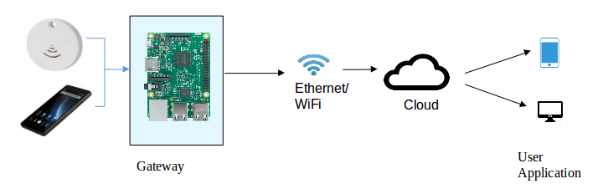

## 3.2 Internal Interfaces

None as of now

## 3.3 External Interfaces

SQL Database

Application

# 4 Design

## 4.1 Flowcharts

## 

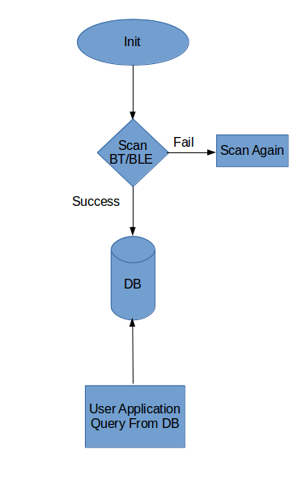

## 4.2 Development Environment

Vi Editor

GCC (Compiler)

SQL

## 4.3 IP Identified

As of Now NO

# 5 Implement

## 5.1 System Requirements

Digital Campus provides below features through various APIs categorized below:

* Scan and Discover BT/BLE Devices
* Store To Database
* User Application

### 5.1.1 <Module based> Functional Requirements

|  |  |  |
| --- | --- | --- |
| SL # | Requirements | Description |
| 1 | REQ - DC001 | User can locate last known/Current location of employee |
| 2 | REQ – DC002 | User can query In/Out time of employee |
| 3 | REQ – DC003 | User can get Dwell Time of Employee |
| 4 | REQ – DC004 | User can get number of employee’s by gateway |

## 5.2 User Acceptance Criteria

* Gateway Should able to Scan Continuously for BT/BLE Devices and push to database
* User Application Should able to Query/Filter Details from database as required I.e Employee location, Dwell Times

## 5.3 Quality Plan

Quality Assurance Plan of Votary Softech Solutions will be followed. Please refer the Quality Assurance plan of Votary Softech Solutions Pvt. Ltd.